The Soil . . .
The first secret to lush, healthy plants is soil preparation. Amending clay soil to allow air and water to penetrate and amending sandy soil so that it will hold more air and water are critical first steps for any gardener. Potting soil, whether homemade or store-bought, should include a soil blend that has just the right consistency. But it also needs additional nutrients a good balance to help plants produce profuse blooms and healthy foliage.

Nitrogen
Through their roots, plants drink up the nitrates in soil. These are made when microscopic organisms, such as fungi, molds and bacteria, break down organic material in soil--first to ammonia, then to nitrites and finally to nitrates. These organisms require nitrogen to do their work. If potting soil doesn't contain enough nitrogen to assist the organisms, they will use whatever is already available in the soil and deplete it of the nutrients that the plant needs. Organic material such as leaves, peat moss, compost and manure provide the nitrogen the tiny organisms consume. The first number on a bag of fertilizer indicates the percentage of nitrogen it contains, for example, 10N-8P-6K.

Phosphorus
If there is not enough phosphorus in the soil, the plant will grow slowly. Phosphorus helps a plant conduct photosynthesis to convert the energy from the sun into energy it can use. The percentage of phosphorus in a fertilizer blend is indicated by the second number listed on a fertilizer label. You'll find phosphorus in a blended mix with nitrogen--10N to 8P--or in a more highly concentrated form in bone meal (0N-23P), super-phosphate (0N-20P) or ammonium phosphate (16N-20P). Acid soils, such as those in wooded areas, commonly need more phosphorus added than more alkaline soils.

Potassium
The last nutrient listed on fertilizer labels, potassium, is indicated by a "K." This nutrient is essential for many parts of a plant's life, such as cell division and the manufacture and movement of sugars and starch that are needed for growth. A balanced blend of nitrogen, phosphorus and potassium in potting soil would be 10N-8P-6K.

Other Minerals
Potting soil and garden soil all contain trace elements of many nutrients that plants need. These include sulfur, magnesium, calcium, iron, zinc and manganese, Because plants need so little of these elements, manufacturers do not add these to bagged potting soil.

Crop Rotation NPK

NPK – Plant Nutrients “Nitrogen” “Phosphorus” “Potassium”

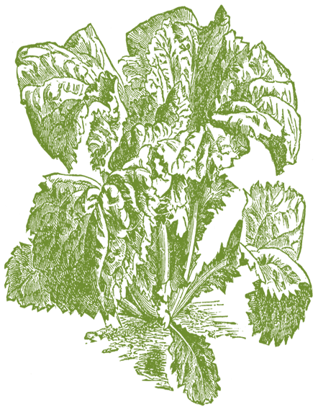
Nitrogen
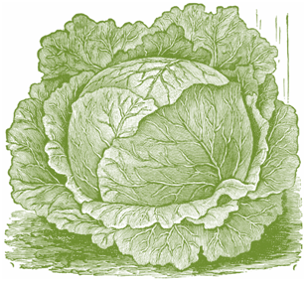

Phosphorus
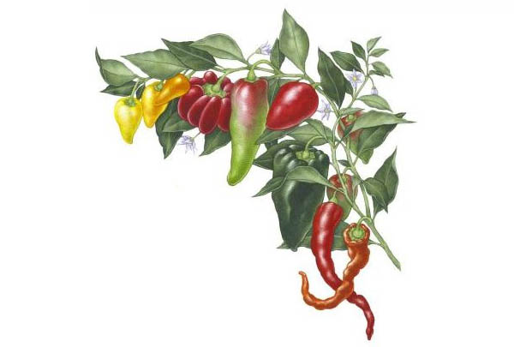

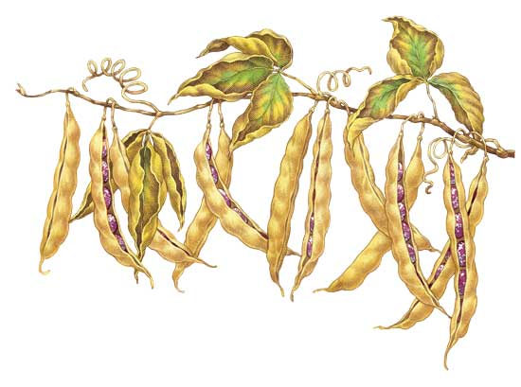

Potassium
